Below is a simple outline for an email to send to Dealers and Contractors to promote the Time Savings benefits of ADP.
Please copy and paste the below content as it is – direct links to the ADP Time Savings landing page have already been created for you.
Let us know if you need any further assistance!
Your ADP Marketing Team / marketing@adpnow.com

Dear [name],
As a pro in the field, you know how valuable your time is. Our easy to install coils allow you to shorten installation time, resulting in time savings and increased revenue.
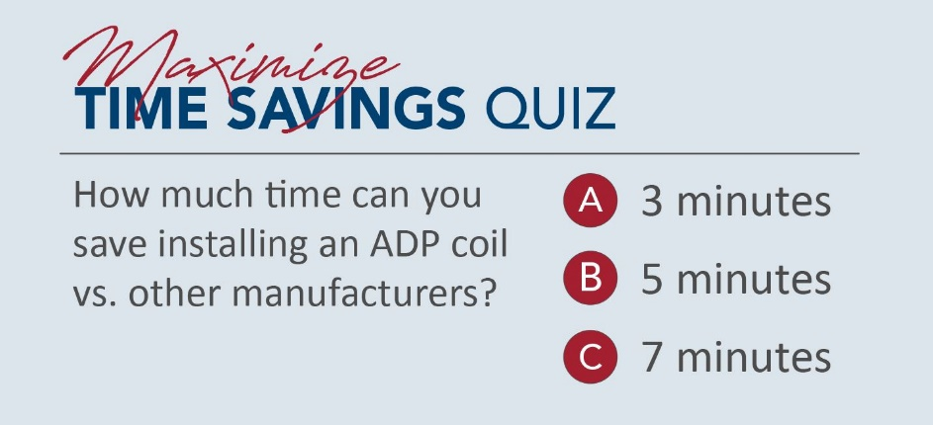
Choose an answer above or click HERE for an exciting video to see the time savings for yourself!

